Name: Ashutosh Soni Id – 2018ucp1505

LAB - 1

**Data Base Management System**

--------------------------------------------------------------------------------------------------------------------------------------

Q1:

Ans: Database with Id-2018ucp1505 had been created and inside it the tables as per name are created. The final table shown below

1. Customer Table:

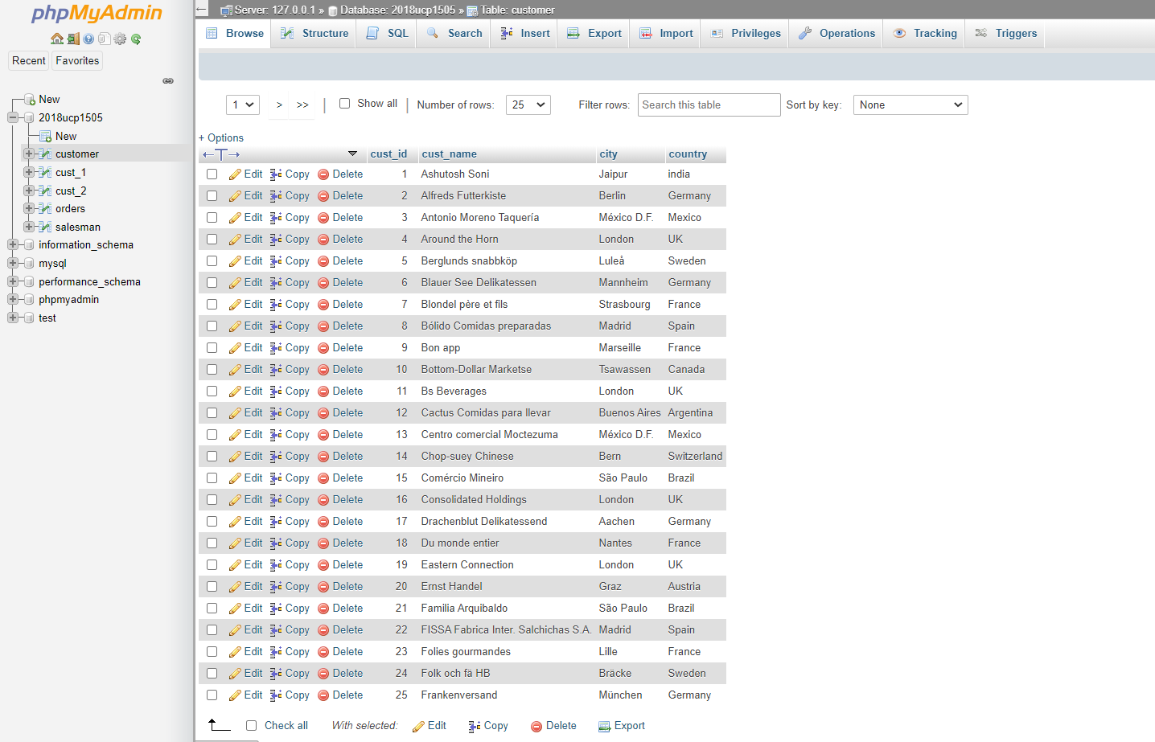

1. 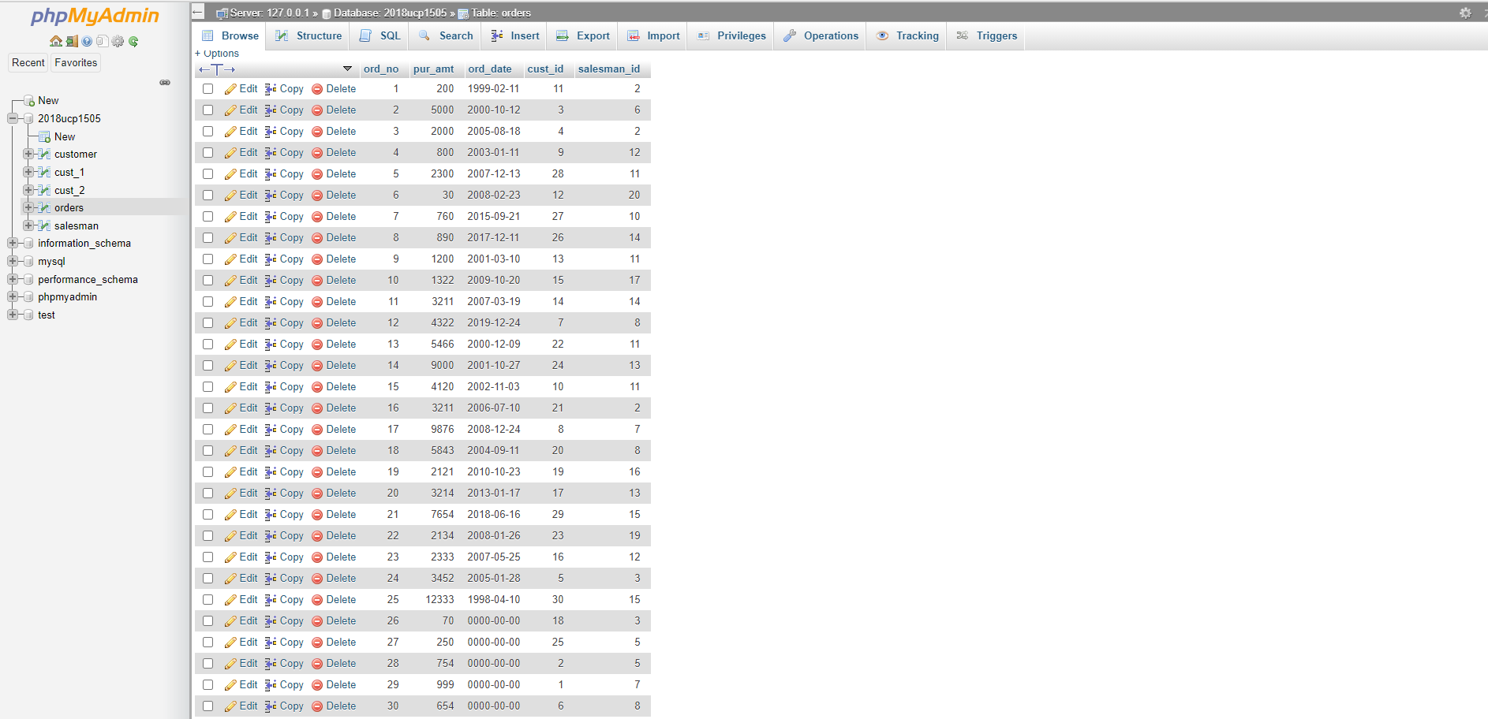Orders Table:
2. Salesman Table:

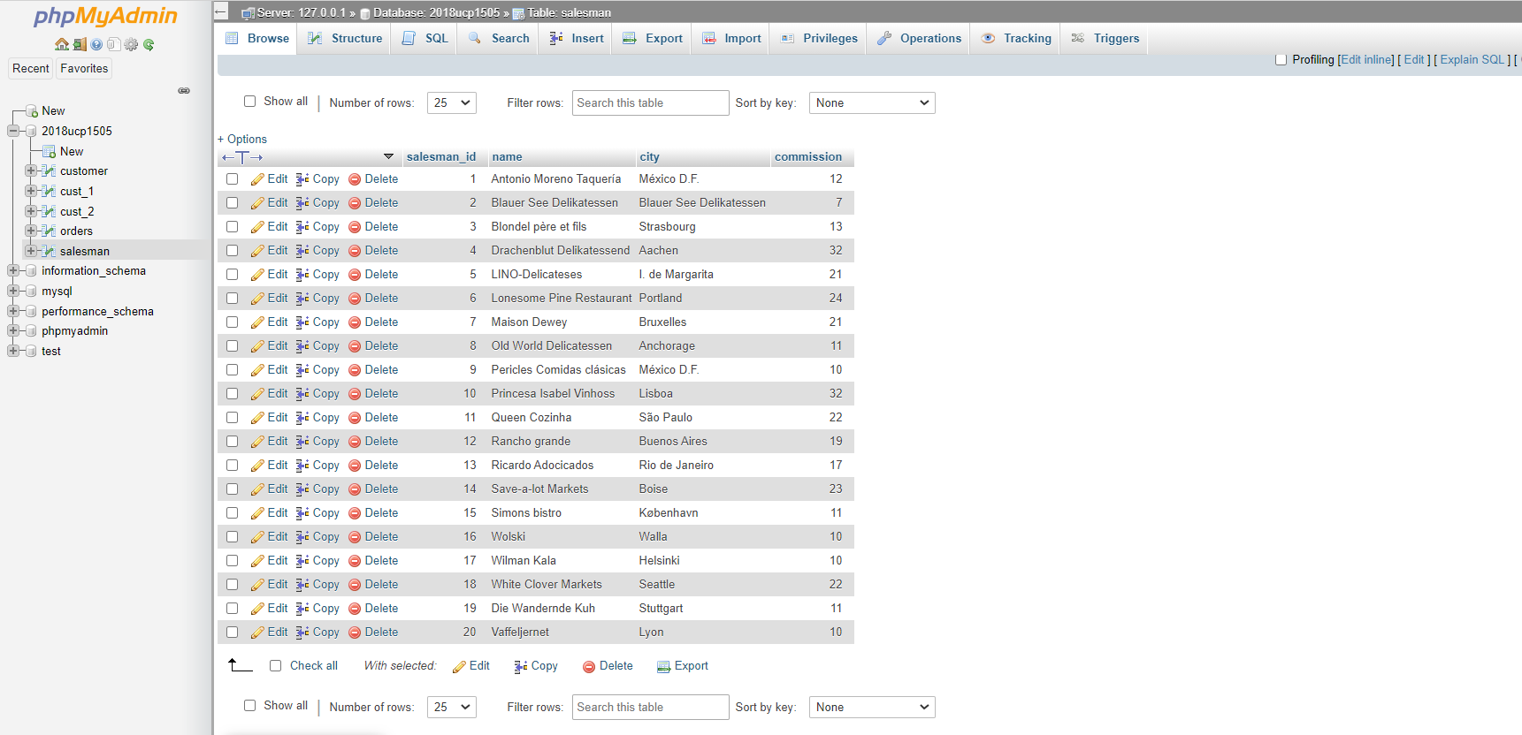

Q2: WAQ (separate for each table) to insert single row of data in the table.

Ans: Query:

INSERT INTO ‘customer’(‘cust_id’, cust_name’, ‘city’, ‘country’)

VALUES (1, ‘ASHUTOSH SONI’, ‘JAIPUR’, ‘INDIA’)

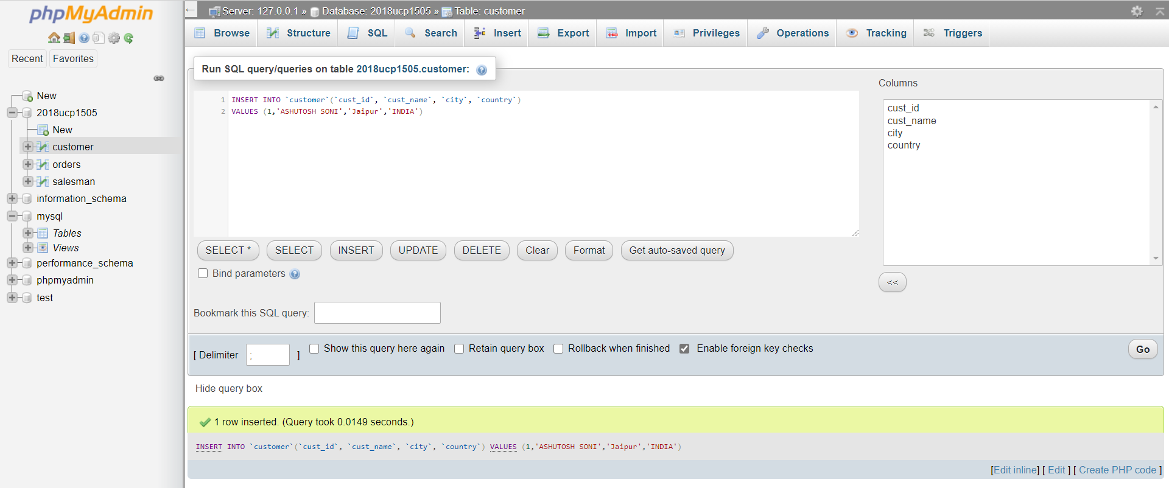

Q3: WAQ (separate for each table) to insert multiple row of data in the table.

Ans: Query:

INSERT INTO ‘customer’(‘cust_id’, cust_name’, ‘city’, ‘country’)

VALUES

(3, ‘Antonio Moreno Taqueria’, ‘Mexico D.F. ’, ‘Mexico’),

(4, ‘Around The Horn’, ‘London’, ‘UK’),

(5, ‘Berglunds Snabbkop’, ‘Lulea ’, ‘ Sweden ’),

(6, ‘Blauer See Delikatessen’, ‘Mannheim ’, ‘Germany’),

(7, ‘Blondel pere et fils’, ‘Strasbourg ’, ‘France’),

(8, ‘Bolido Comidas preparadas’, ‘Madrid ’, ‘Spain’),

(9, ‘Bon app’, ‘Marseille ’, ‘France’),

(10, ‘Bottom-Dollar Marketse’, ‘Tsawassen ’, ‘Canada’);

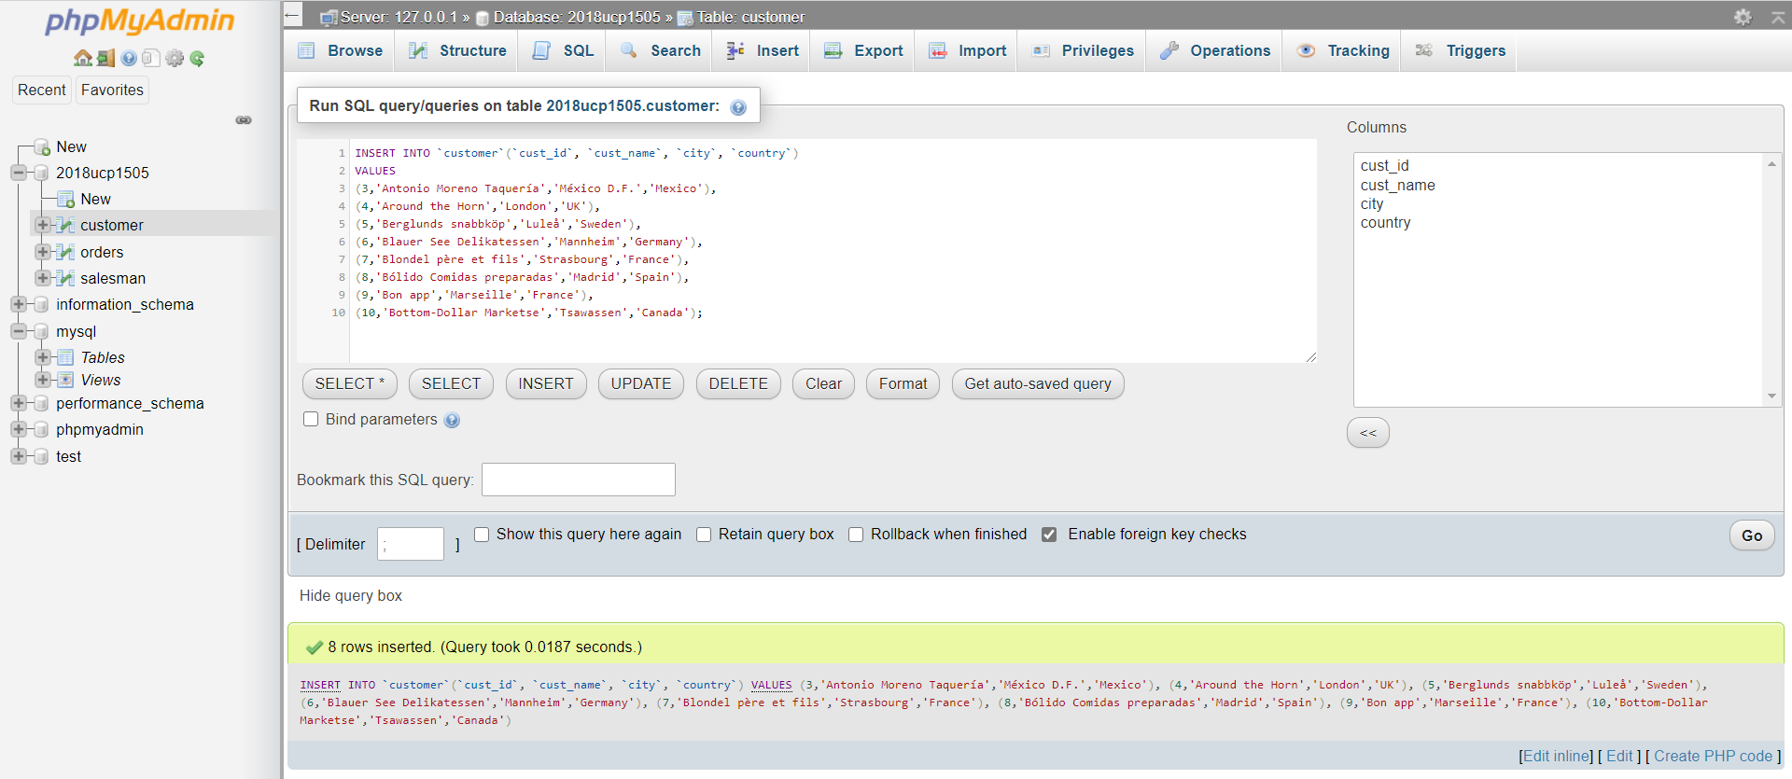

Q4: Write a query to list all customers with order amount greater than 1000 using subquery.

Ans: Query:

SELECT cust_name,pur_amt FROM customer,orders

WHERE customer.cust_id = orders.cust_id AND pur.amt > 1000;

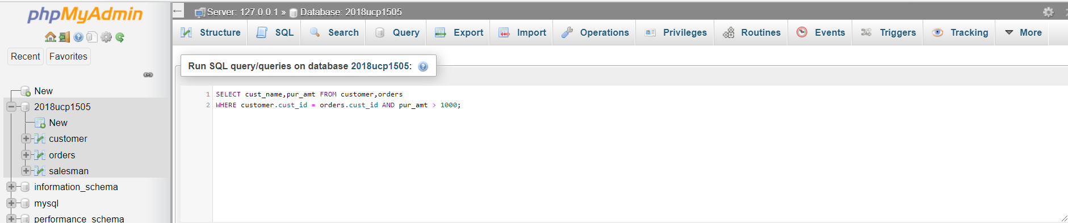

Query after execution:

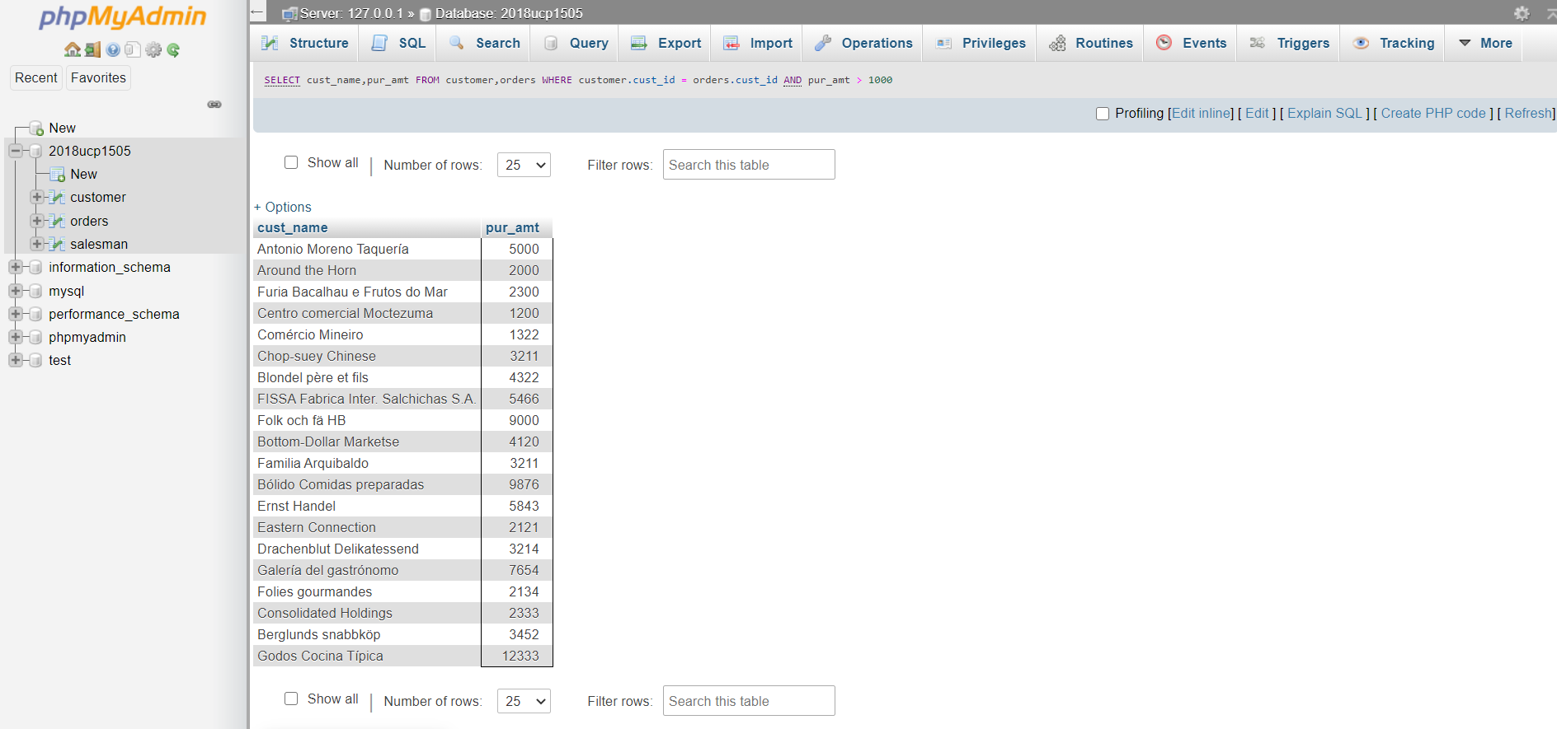

Q5: Write a query to list all customers with their total number of orders using subquery.

Ans: Query:

SELECT cust_name, city, country, ord_no FROM customer, orders

WHERE customer.cust_id = orders.cust_id

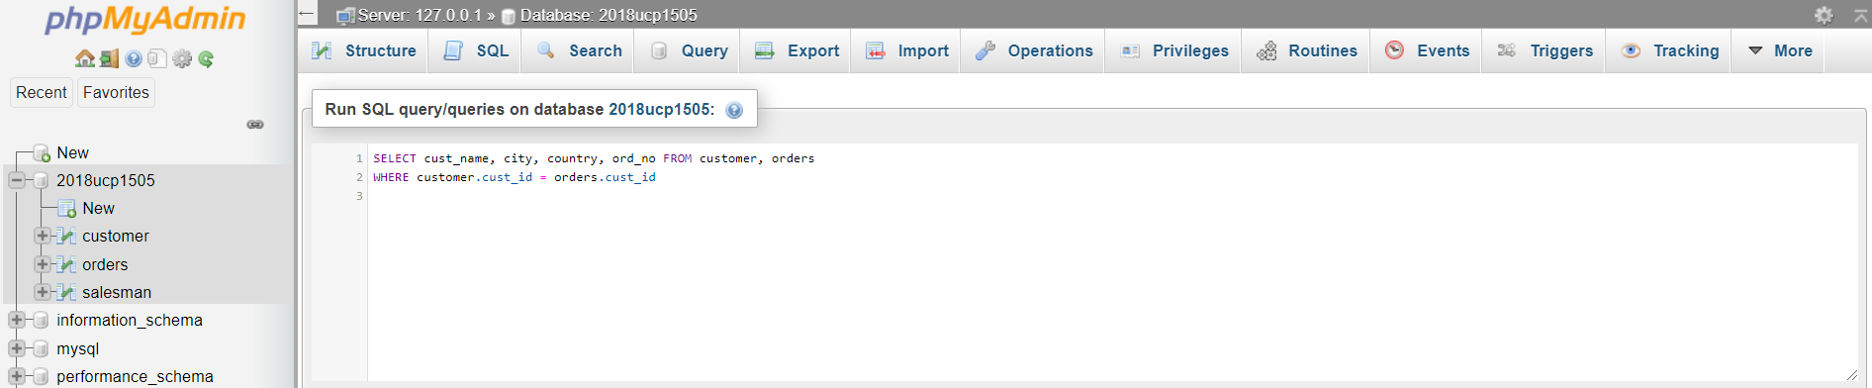

Query after execution:

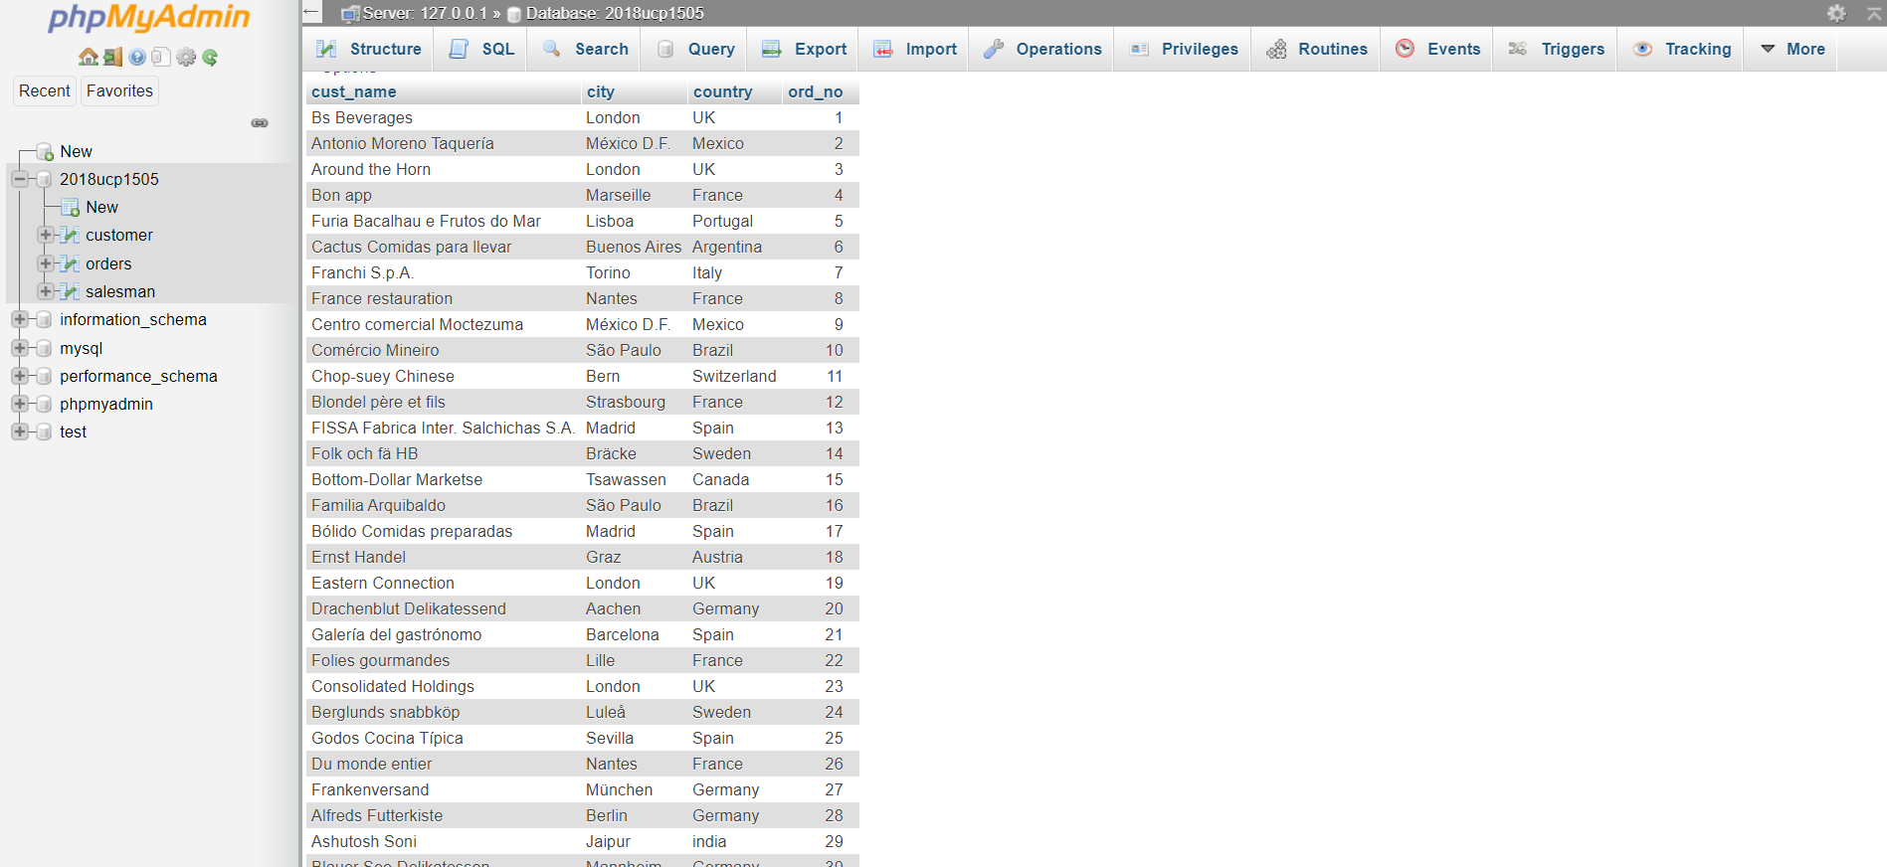

Q6: Write a query to find all the orders with order amounts which are above average amount for

their customers using subquery.

Ans: Query:

SELECT * FROM ‘orders’

WHERE pur_amt > (SELECT AVG(pur_amt) FROM orders )

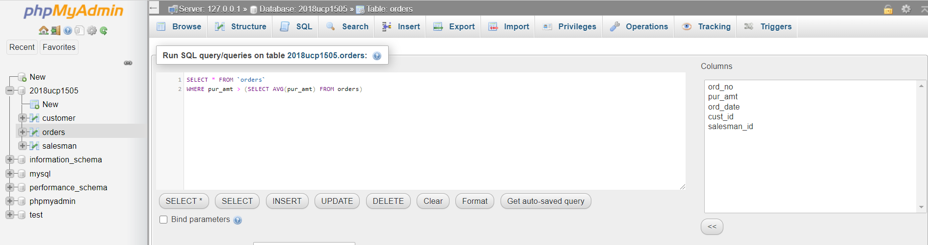

Query After execution:

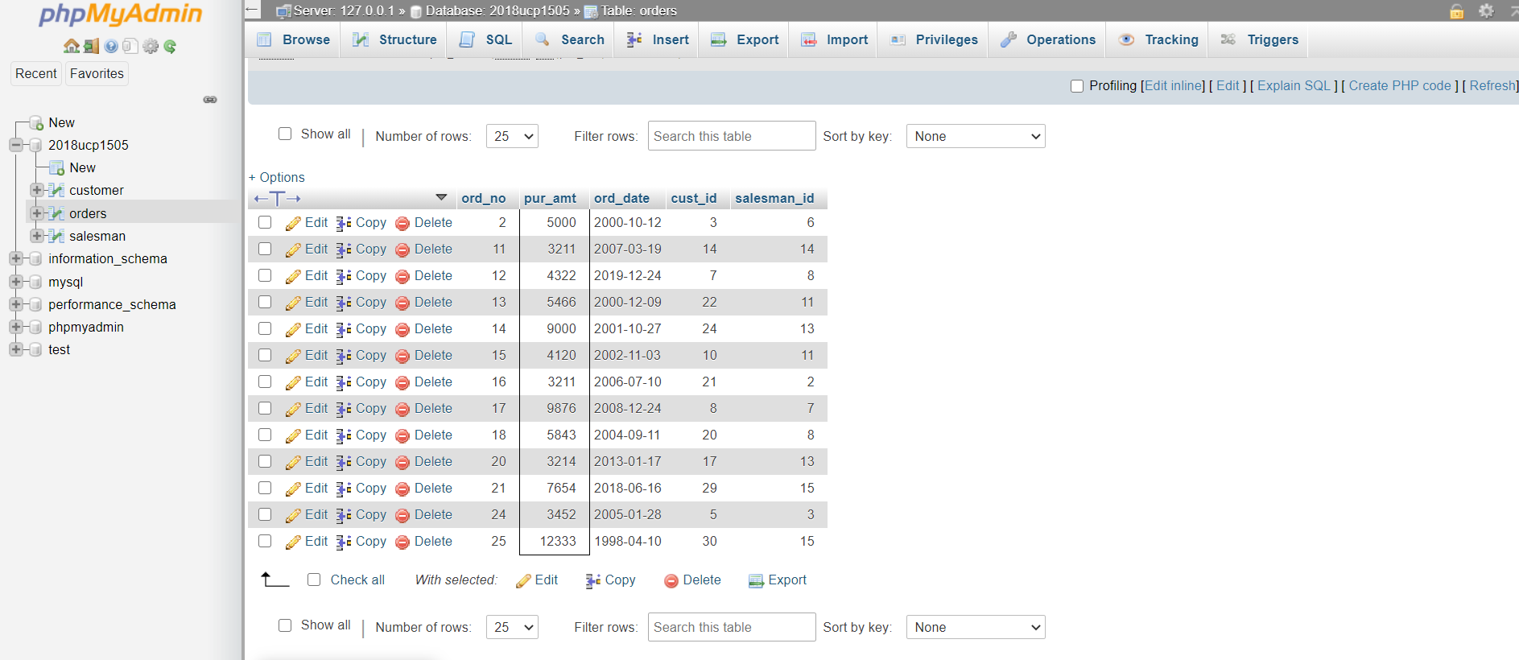

Q7: Given that you have a table named Customer in your database. Write a Create table statement

to create another table Cust_1 with same structure and data as that of Customer.

Ans: Query:

CREATE TABLE IF NOT EXISTS Cust_1

SELECT * FROM customer;

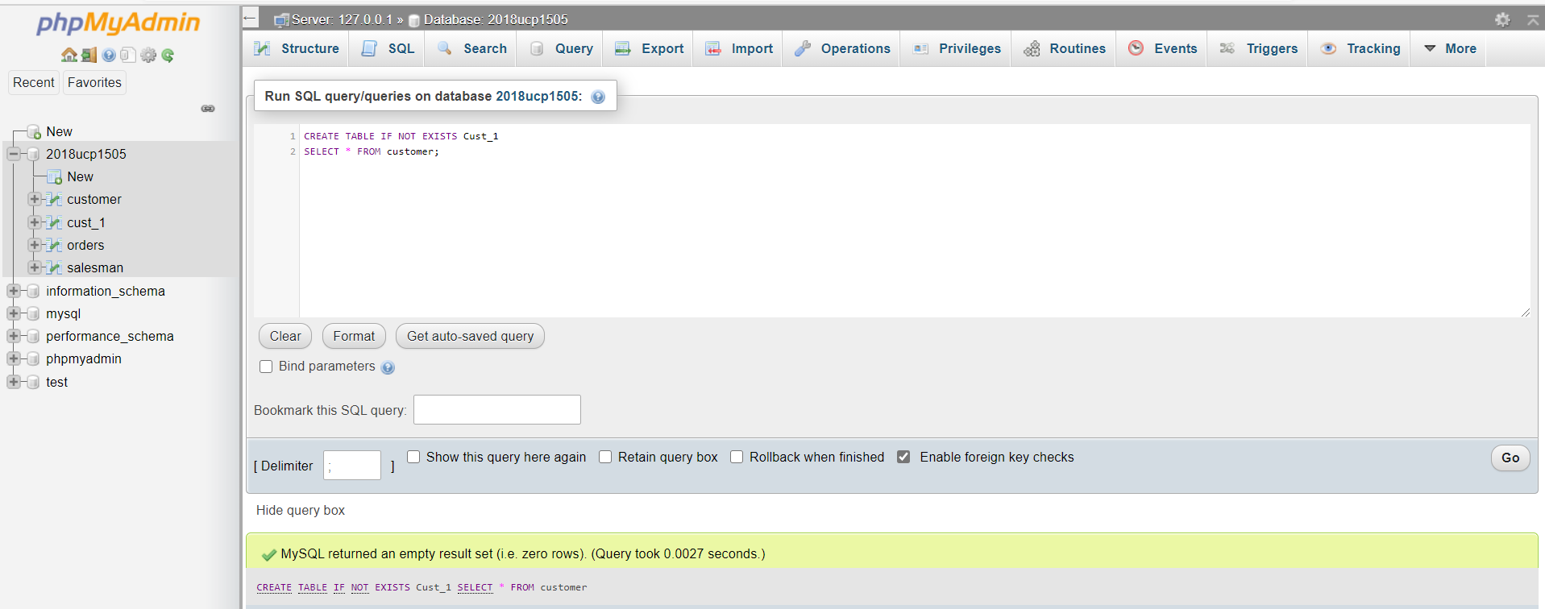

Query after execution:

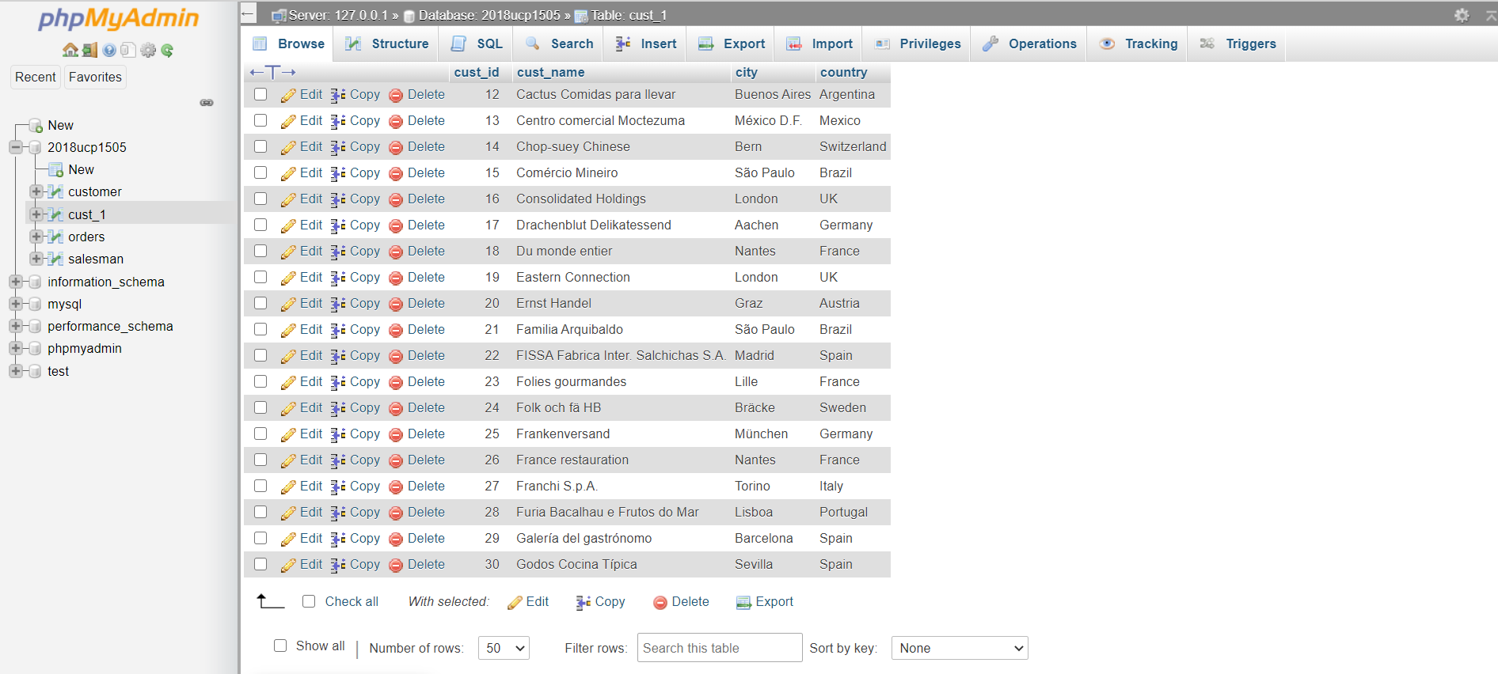

Q8: Given that you have a table named Customer in your database. Write a Create table statement

to create another table Cust_2 with same structure (but with no data) as that of Customer.

Ans: Query:

CREATE TABLE Cust_2 LIKE customer;

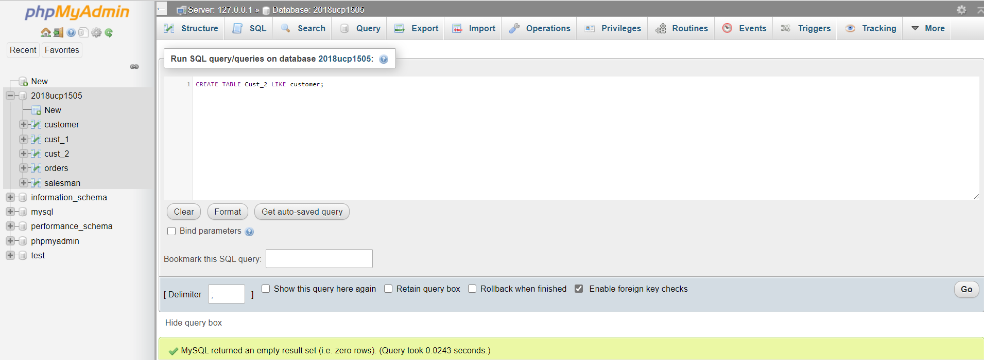

Query after execution:

